Mid Lab
Object Oriented Programmin

Submitted by :
Ubaid Ahmad
Roll No:
2410-0011
Submitted To:
Ma’am Laiba Tanveer

Date: 11/11/2025

Task 1
//-----------------------Ubaid AHmad------------2410-0011
#include <iostream>
using namespace std;
int x=0; //used in distructure
class StudentRecord{
string name;
int rollNo;
int marks[3];
public:
static int count;
StudentRecord(){
name="newStudent";
rollNo=13;

count++;
}
StudentRecord(string s,int r){
name=s;
rollNo=r;

count++;
}

void setmarks(){
for(int i=0;i<3;i++){
cout<<"Enter maarks in subject "<<i+1<<" ";
cin>>marks[i];
}
}

int totalMarks(){
int sum=0;
for(int i=0;i<3;i++){
sum+=marks[i];
}
return sum;
}

int average(int sum,int n){
return sum/n;
}

StudentRecord operator+(StudentRecord &s){
StudentRecord temp;
for(int i=0;i<3;i++){
temp.marks[i]=marks[i]+s.marks[i];
}

return temp;
}

void display() const{
cout<<"\nstudent name is: "<<name<<endl;
cout<<"student RollNo is: "<<rollNo<<endl;
for(int i=0;i<3;i++){
cout<<"marks in object "<<i+1<<": "<<marks[i]<<endl;
}
}

~StudentRecord(){
x++;
cout<<"object "<<x<<" finished"<<endl;
}
};
int StudentRecord::count=0;
int main(){
int n=3;

//object 1
StudentRecord s1("Ubaid Ahmad",11);
cout<<"\n Enter marks for student 1"<<endl;
s1.setmarks();
s1.display();
int sum=s1.totalMarks();
cout<<"\nstudent 1 total marks are: "<<sum<<endl;
int avg=s1.average(sum,n);
cout<<"student 1 average is: "<<avg<<endl;

//object 2
StudentRecord s2("Ahmad Ali",12);
cout<<"\n Enter marks for student 2"<<endl;
s2.setmarks();

//object 3
StudentRecord s3=s1+s2;
cout<<"\nstudent 1 data: "<<endl;
s1.display();
cout<<"\nstudent 2 data: "<<endl;
s2.display();
cout<<"\nstudent 3 data: "<<endl;
s3.display();

int totalObj=s1.count;
cout<<"\n in total : "<<totalObj<<" number of objects created"<<endl;
return 0;
}
OUTPUT:
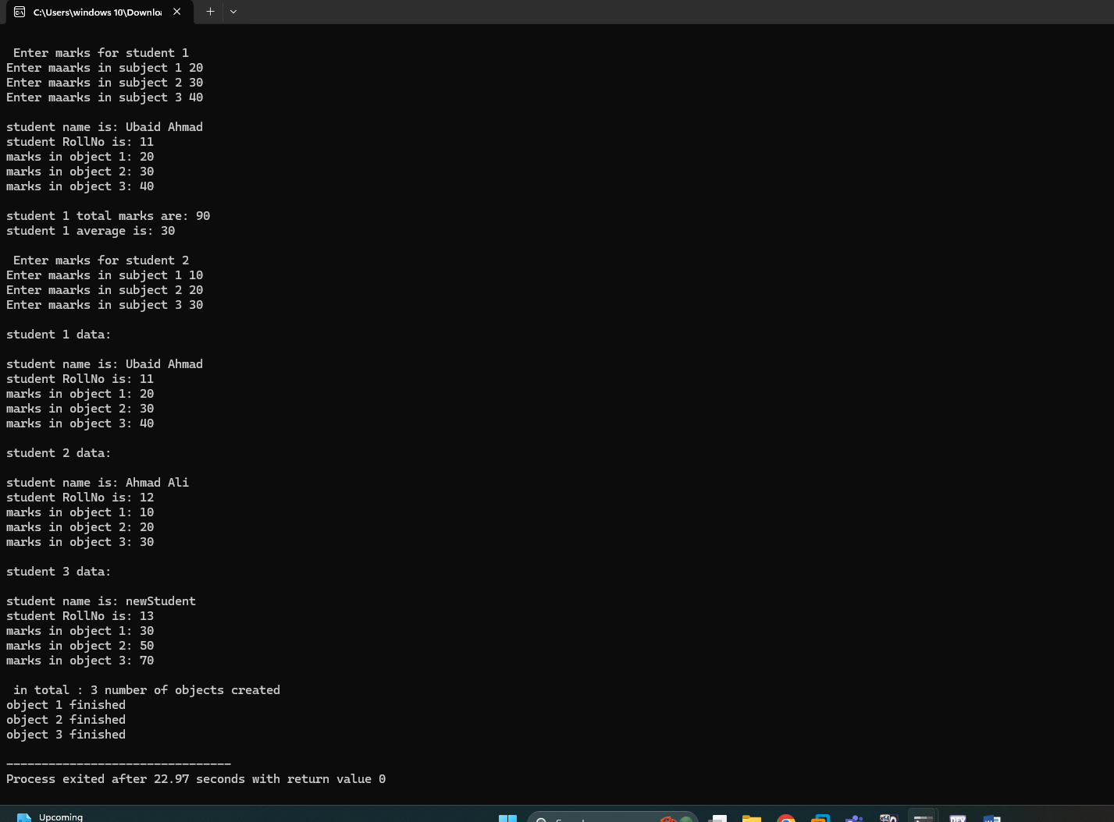
TASK 2
Code:
#include <iostream>
using namespace std;
class WeatherStation {
string name;
int* temprature[3];
int id;
public:
static int count;
WeatherStation(string n, int x) {
name = n;
id = x;
for (int i = 0; i < 3; i++) {
temprature[i] = new int;
}
count++;
}
WeatherStation(WeatherStation& w) {
name = w.name;
id = w.id;
for (int i = 0; i < 3; i++) {
temprature[i] = new int;
*(temprature[i]) = *(w.temprature[i]);
}
count++;
}
void readTemprature() {
for (int i = 0; i < 3; i++) {
cout << "Enter reading: " << i + 1 << " ";
cin >> *(temprature[i]);
}
}
int averageT() {
int sum = 0;
for (int i = 0; i < 3; i++) {
sum += *(temprature[i]);
}
return sum / 3;
}
void display() const {
cout << "location is: " << name << endl;
cout << "id is: " << id << endl;
cout << "temprature readings are: ";
for (int i = 0; i < 3; i++) {
cout << *(temprature[i]) << " ";
}
cout << endl;
}
bool operator>(WeatherStation& w) {
int a = this->averageT();
int b = w.averageT();
return a > b;
}
~WeatherStation() {
for (int i = 0; i < 3; i++) {
delete temprature[i];
}
cout << "memory cleared " << endl;
}
};
int WeatherStation::count = 0;
int main() {
WeatherStation w1("pakistan", 24);
cout << "Enter temprature of last 3 days for station 1" << endl;
w1.readTemprature();
int average = w1.averageT();
cout << "\nStation 1 average temprature is: " << average << endl;
cout << "\nStation 1 display" << endl;
w1.display();
WeatherStation w2(w1);
cout << "\nStation 2 display" << endl;
w2.display();
WeatherStation w3("Iran", 50);
cout << "Enter temprature of last 3 days for station 3" << endl;
w3.readTemprature();
cout << "\nStation 3 display" << endl;
w3.display();
if (w1 > w3) {
cout << "\nStation 1 average is greater than station 3" << endl;
} else {
cout << "\nStation 3 average is greater than or equals station 1" << endl;
}
int c = w1.count;
cout << "\ntotal " << c << " number of stations created" << endl;
return 0;
}
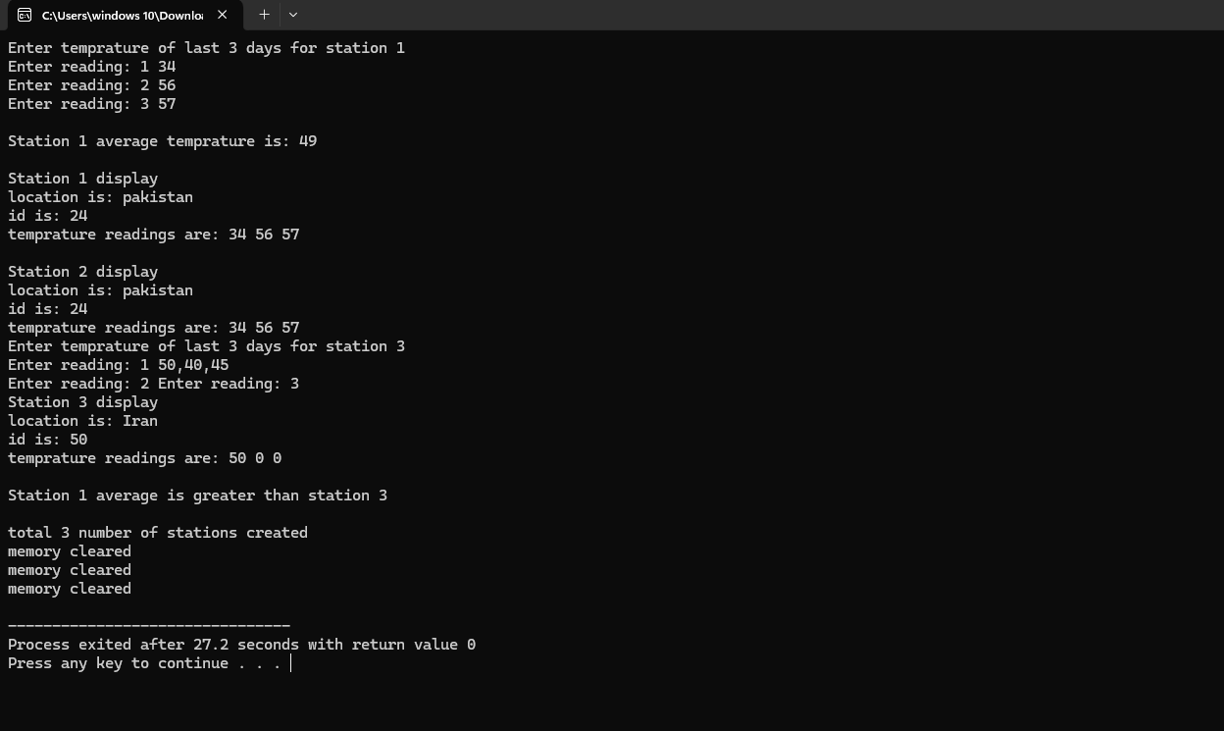
END,,,

